**Experiment 10**

**Aim:** Shell Script to determine whether given number is prime.

**Software:** Ubuntu

**Procedure:**

* Using command #gedit create a file with .sh extension name it prime.sh
* Enter the given Shell Script in the file.

#Varad Patil 120A2036

echo -e "Enter Number\c"

read n

for ((i=2;i<=$n/2;i++))

do

 ans=$((n%i))

  if [$ans -eq 0]

  then

   echo "$n is not a prime number"

   exit 0

   fi

   done

   echo "$n is a prime number"

* Use commands #chmod +x filename.sh to give execution rights to the file.
* Then ./filename.sh to launch the file.
* Enter the number.
* Finally we get if the given number is prime.

**Output:**

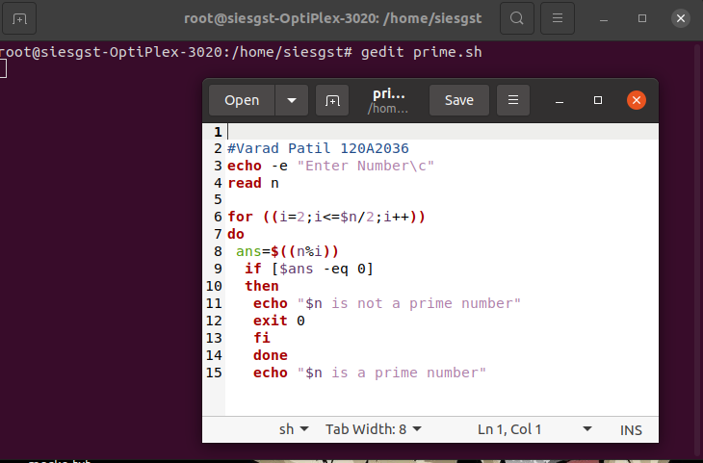

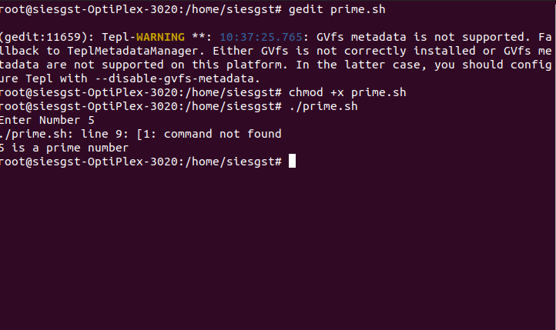

**Conclusion:**

The shell script to determine whether given number is prime was performed successfully.